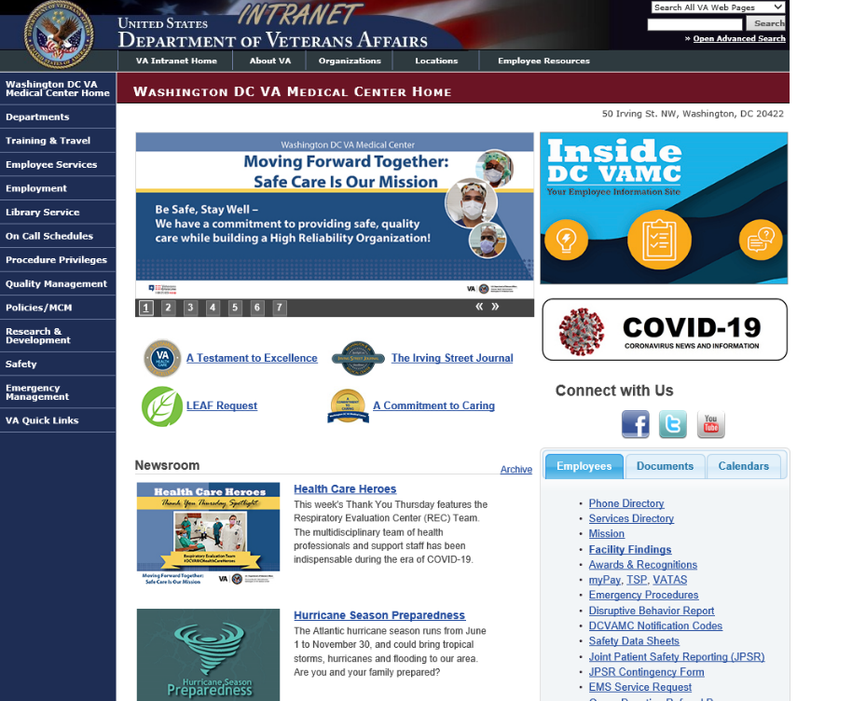
From a VA Computer, open Internet Explorer. The VA Intranet home page should appear (Figure 1).
Figure 1. VA Intranet Homescreen

Scroll down until you see the link for the “Remote Access Portal” (Figure 2) and click the link:
Figure 2. Link to Remote Access Portal - RAP
A pop-up will appear (Figure 3). Click “Accept and Continue”.
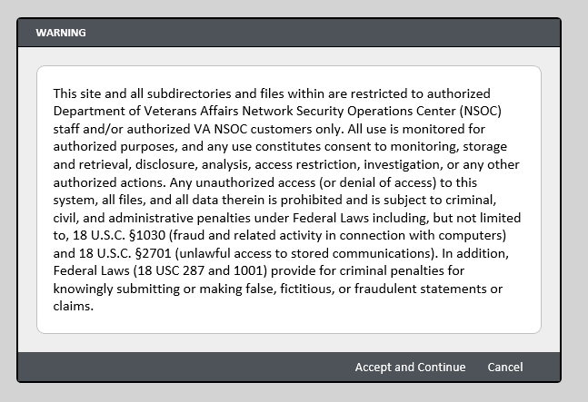
Figure 3. Security Pop-up

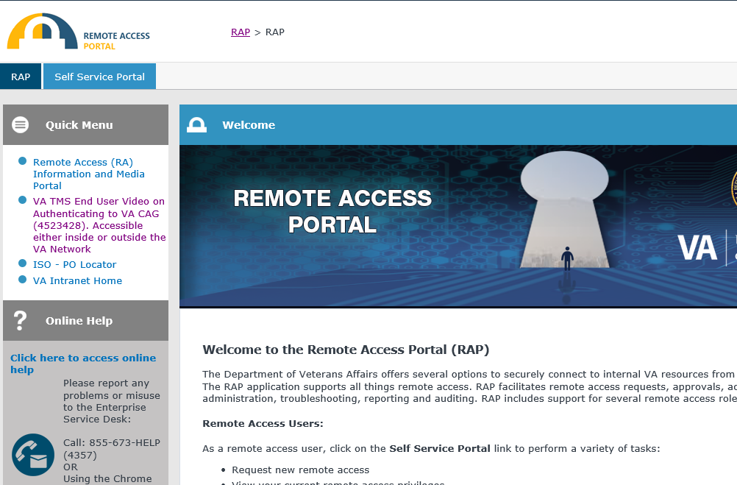
The Remote Access Portal will open. Click on the “Self Service Portal” link (Figure 4).
Figure 4. Remote Access Portal -> Self Service Portal

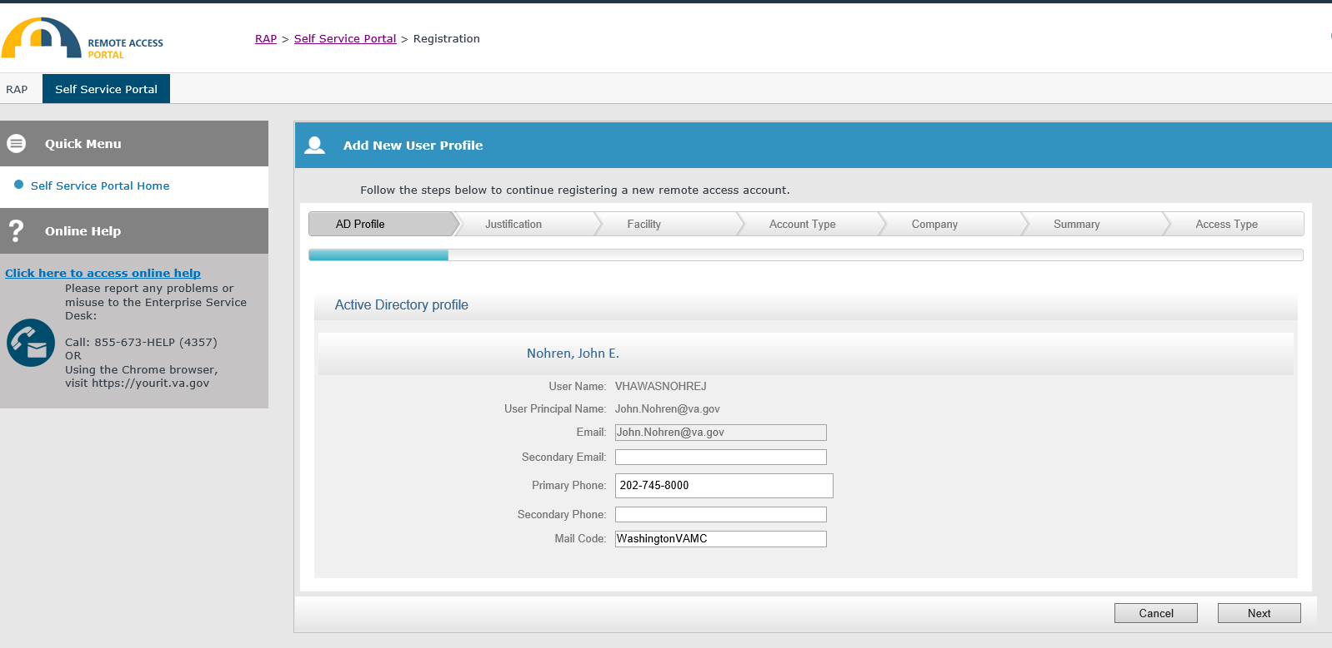
The “Add New User Profile” screen will appear with prepopulated information. Enter your preferred email in the “Secondary Email” text box. Click “Next” to continue (Figure 5).
Figure 5. Add New User Profile Screen

The “Justification” screen will appear (Figure 6). In the “Justification for the account” text box, please type in the name of your program and that you are an Internal Medicine Resident, for example "George Washington Internal Medicine Resident.” Click “Next” to continue.
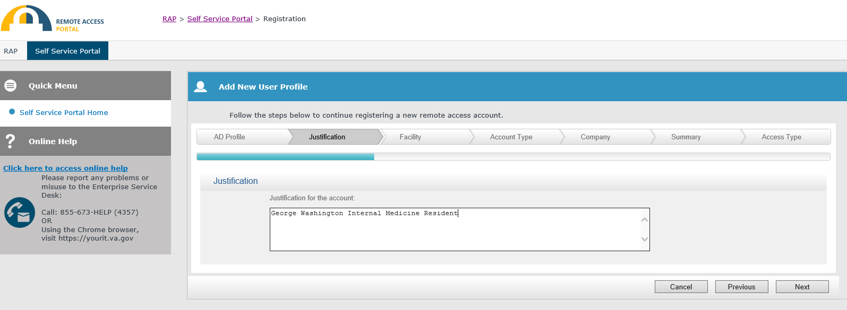
Figure 6. Justification for the Account

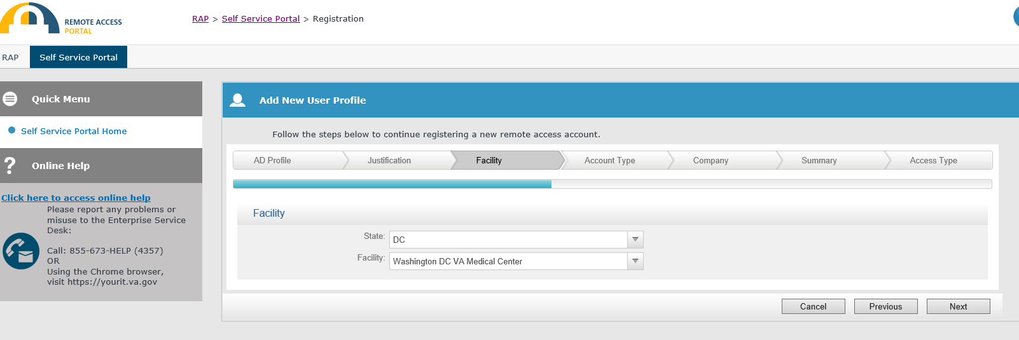
The “Facility” screen will appear (Figure 7). select “DC” from the State dropdown menu, and select “Washington DC VA Medical Center” from the Facility dropdown menu. Click “Next” to continue.
Figure 7. Facility Screen

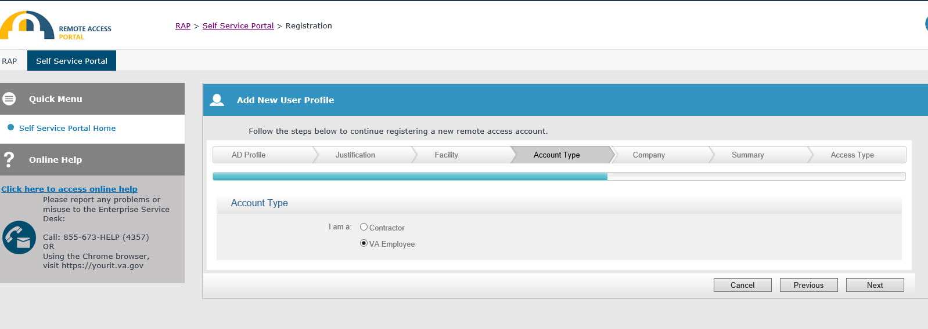
The “Account Type” screen will appear (Figure 8). Select the radio button for “VA Employee.” Click “Next” to continue.
Figure 8. Account Type Screen

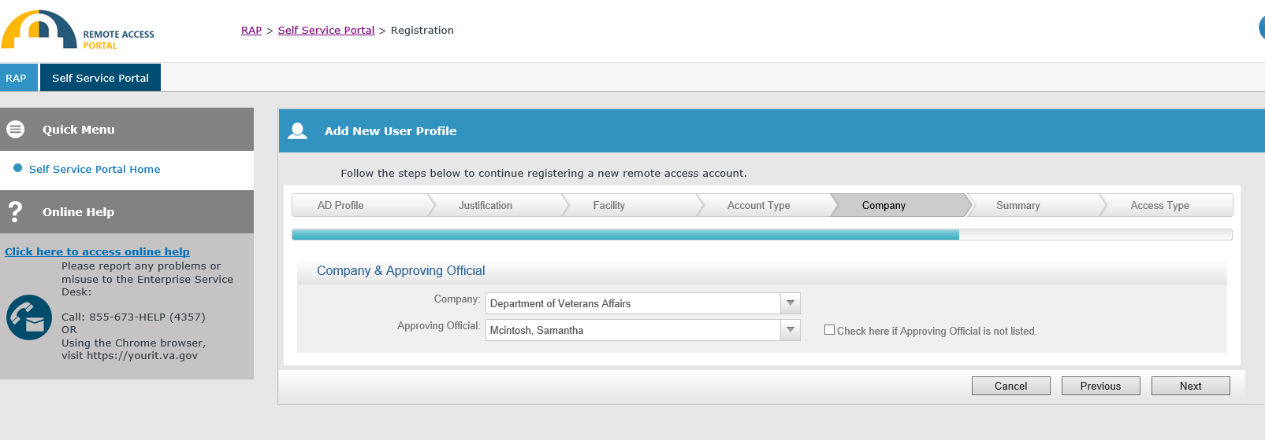
The “Company” screen will appear (Figure 9). In the “Company” drop down menu, select “Department of Veterans Affairs.” In the “Approving Official” drop down menu, select “Tuck, Matthew.” Click “Next” to continue.
Figure 9. Company Screen

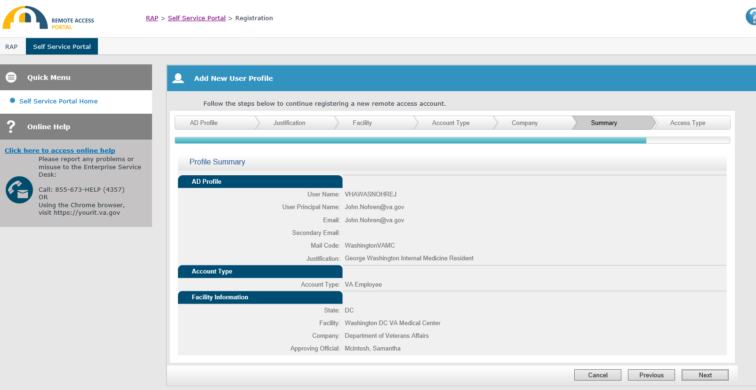
The “Summary” screen will appear (Figure 10). Please review your Profile Summary and ensure that everything is correct. Click “Next” to continue.
Figure 10. Summary Screen

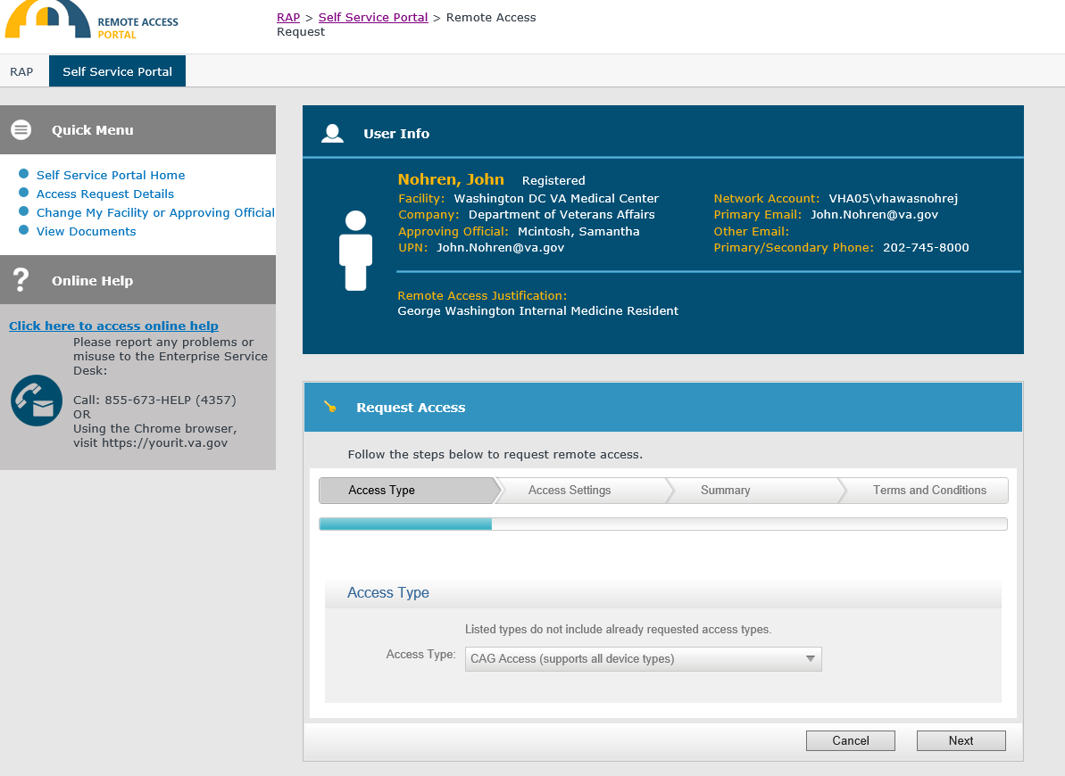
You have now completed your User Profile. Your information should show up as “User Info” in your Self Service Portal (Figure 11). You may now request remote access. Begin by selecting “CAG Access” from the Access Type drop down menu (Figure 11).
Figure 11. User Profile Screen and Access Type

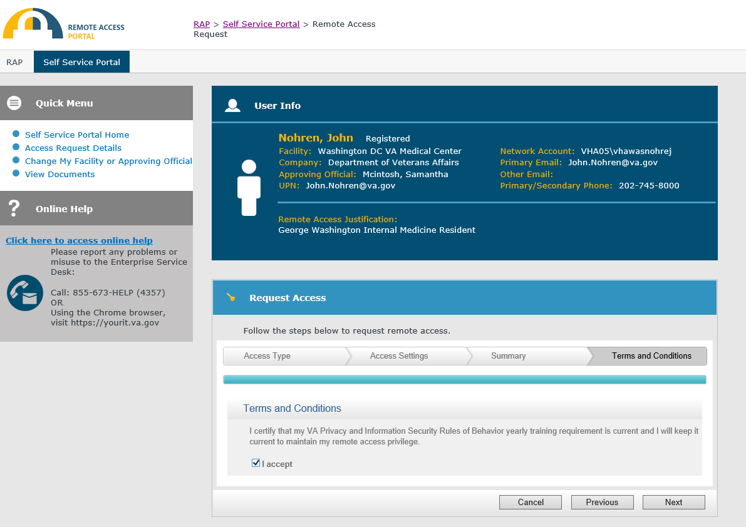
The system will automatically advance you to the “Terms and Conditions” tab (Figure 12). Please check the box for “I accept.” Click “Next” to continue.
Figure 12. Terms and Conditions Tab

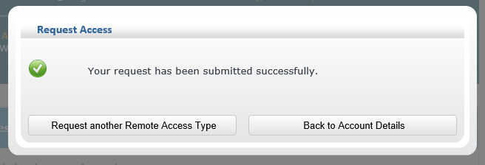
A pop-up will appear, indicating that your request has been submitted successfully (Figure 13). Your request will then be sent to the Approving Official for additional approval. You will receive an email to your VA email account with further instructions once you have been approved.
Figure 13. Remote Access Request Submitted Successfully

