Purpose
To establish secure, compliant, and standardized procedures for Radiology CD creation and CD import activities.
Radiology technologists are not responsible for burning CDs or importing external CDs into PACS. All CD creation and import activities must be performed by ROI staff.
Adherence to this policy is required to maintain patient privacy, data integrity, and compliance with institutional and regulatory standards.
CD Creation Procedures: Hours (Monday–Friday, 0800–16:00)
• All CDs will be burned by ROI staff only.
• Technologists will not burn CDs.
• Email the Release of Information Request for Continuation of Care to the ROI department at VHAWASROISTAFF@VA.GOV.
- Routine requests will be processed within 48hrs.
- If needed in less than 48hrs, email the same request form AND call the ROI Department at ext. 57100 to confirm receipt and pick up location:
  - TCM / ROI Office IE-610
  - HIMS Department BH-135
CD Creation Procedures: After-Hours and Weekend Emergencies
- The AOD/Designee will push the exam from the PACS workstation to the PACS Cube CD burner on the first floor in the TCM ROI Office 1E-610.
  - If an AOD/Designee does not have access to a PACS workstation, they can ask radiology technologist for assistance in pushing the exam to the PACS Cube Burner.
- The Provider or RN will complete and sign the ROI form and submit it to the AOD.
- The AOD will retrieve and provide the CD to the provider.
  - The AOD will maintain keys for TCM ROI 1E-610
Downtime during Afterhours and weekends:
- The AOD/Designee will push the exam from the PACS workstation to the PACS Cube CD burner located in HIMS office (Basement BH 135)
  - If a AOD/Designee does not have access to a PACS workstation, they can ask radiology technologist for assistance in pushing the exam to the PACS Cube Burner.
- The Provider or RN will complete and sign the ROI form and submit it to the AOD.
- The AOD will retrieve and provide the CD from BH 135 and hand off to the provider.
CD Import Procedures
- Technologists will not upload external exams into PACS
- ROI will upload all CDs to PACS in accordance with security requirements
- STAT request for CDs that need to be imported can be delivered to Health Information Management Department BH-135 for immediate processing
- Standard requests can be put in the Dropbox located in TCM or Radiology department

Instructions to burn a CD From PACS station
- Right Click on exam or exams that need burned
- Select Send Study
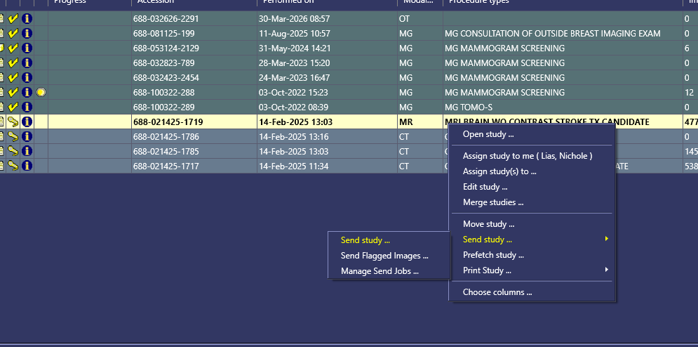

- Select WAS-1E610 PacsCube Burner
- Click Send Study
