Virtual beds tip sheet:
- The ED is considered an outpatient area in the VA. A virtual bed allows us to move a patient to an inpatient status and order medications/write notes for them. The purpose of virtual beds is to get ED boarders to the right level of care and hopefully move admits to earlier in the day so the night teams don’t get slammed.
- This should work just like putting in regular medicine orders
- You should not be prompted to place delayed orders when a patient is in a virtual bed(if so this means there is no ADT order and a virtual bed wasn’t entered correctly)
- You will know the patient is in a virtual bed when you see the yellow banner say EDV
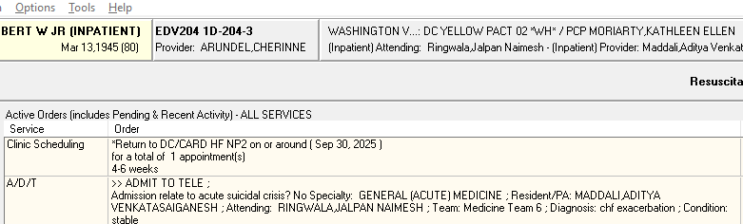
- ***** Important step: once the patient moves to their bed upstairs, some of the orders may say EDV under location. If that happens, right click and highlight the order, then click renew.
- This is a pilot so please let me, Cherinne Arundel or one of the chiefs, know if there are issues (orders falling off etc.) Can reach me by cell, 561-707-5836, teams or email cherinne.arundel@va.gov
- You can reach out to admissions at ext 54180 if there is a delay in the patient moving to a virtual bed or if you are prompted enter delayed orders.
- ED charge nurse can be reached via vocera or at 5-8357
Virtual patients going to PCU/MICU
- The flow center will notify you if a virtual patient is going to PCU/MICU/SICU.
- A patient may need a tele or isolation bed and the only bed available in the hospital is a PCU or MICU bed. If this happens, the orders may fall off so need to convert your virtual orders to delayed orders (we are working on fixing this).
- Write "Delayed Orders." You can write delayed orders for anyone who is moving from one location to another (ie. PCU to Med/Tele). This also applies for new ED admissions. Click the Order tab>>find "Write Delayed Orders" in a gray box on the left menu bar above where it says "Write Orders">>Click the level of care the patient is planning to receive (ie. Med/Tele)>>fill in the "Delayed" ADT order and then add any other orders. All these orders will automatically move from delayed to active once the patient has a bed in CPRS.
- You can also start an admission note:
  - Notes tab -> New Note -> Encounter Location -> DC/MEDICAL SERVICE​

