|  |  |
| --- | --- |
| Office of Information and Technology |  |

**Follow the instructions below to map to Secure Print.**

**1.In the lower left- hand corner of your screen where it says ‘Type here to search’, key in the following (or copy and paste):**

**\\vhawasprt1\SecurePrint**



**2. Click on the Secure Print icon as show below.**

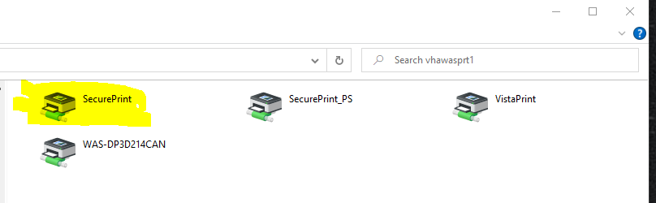

**3. Click on Printer.**

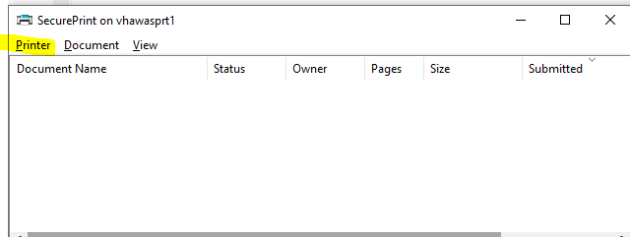

**4. Select ‘Set As Default Printer’ if this is your primary printer.**

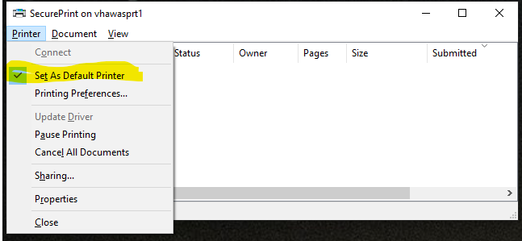

**5. Select Properties to test the printer.**

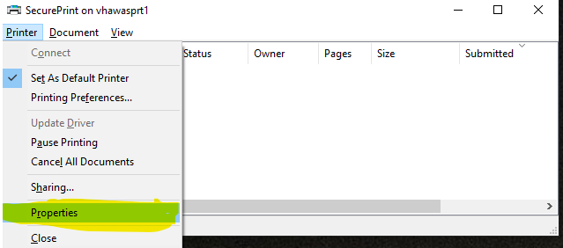

**6. Click on Print Test Page**

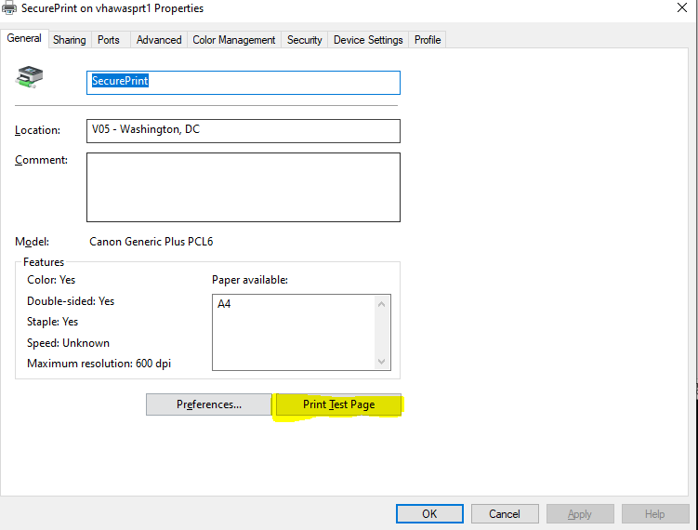

**7. When a window appears indicating that the job has been sent to the printer, log on the Canon MFD and select Secure Print to verify.**

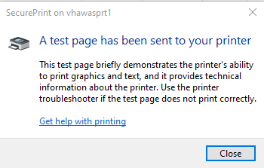

**\*\*It’s highly recommended that you remove Secure-Print on VHAWASAAPPCAN02(see the instructions below)**

**To Remove Secure-Print on VHAWASAPPCAN02**

**1.In the lower left- hand corner of your screen where it says ‘Type here to search’, key in the following:**

**Printers & scanners and hit enter**



**Left-click Secure-Print on vhawasappcan02 on vhawasappcan02 only once**

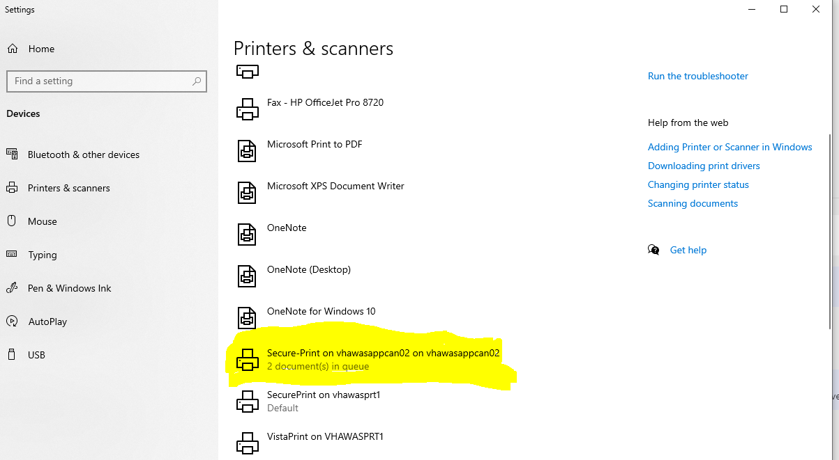

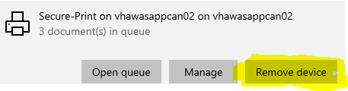

**Select Remove device**

**How to Map to VistA Print**

**For those who print from VistA, please follow the steps below.**

**1.In the lower left- hand corner of your screen where it says ‘Type here to search’, key in the following (or copy and paste): \\vhawasprt1\VistaPrint**



**2. Click on the VistaPrint icon as show below.**

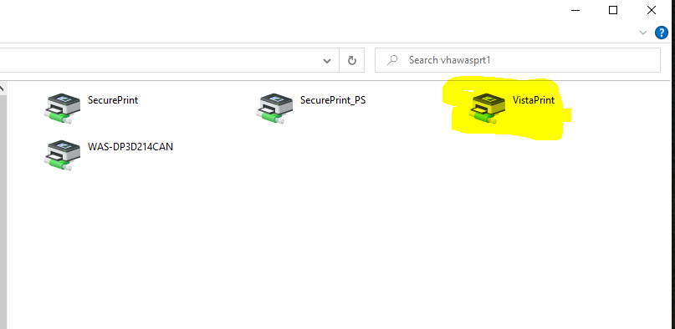

**The window below will appear.**

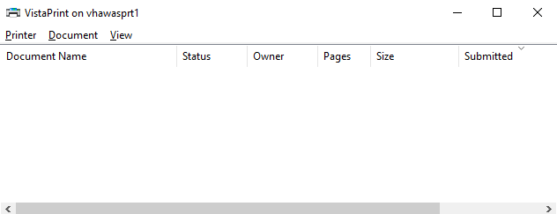

**3. Please type the following name in VistA (WAS-DP1C117PIV-132 or WAS-DP1C117PIV-80) to send jobs to the Canon MFD.**

**If you have an issue connecting to Secure Print or VistA Print, submit a YourIT ticket, and a technician will assist you in a timely matter.

**If you are unable to locate your print job on the MFD, contact the Canon service desk at 1-800-355-1385 and be sure to provide the device’s serial number.